AWS - EBS ,Snapshot

Task : Launch an EC2 instance (Linux and Windows) along with a web server. Then, create an EBS volume of 5 GB, attach it to an EC2 machine (Linux and Windows), and take a snapshot. Finally, create an EBS volume using the taken snapshot.

Launch the Ec2 instance

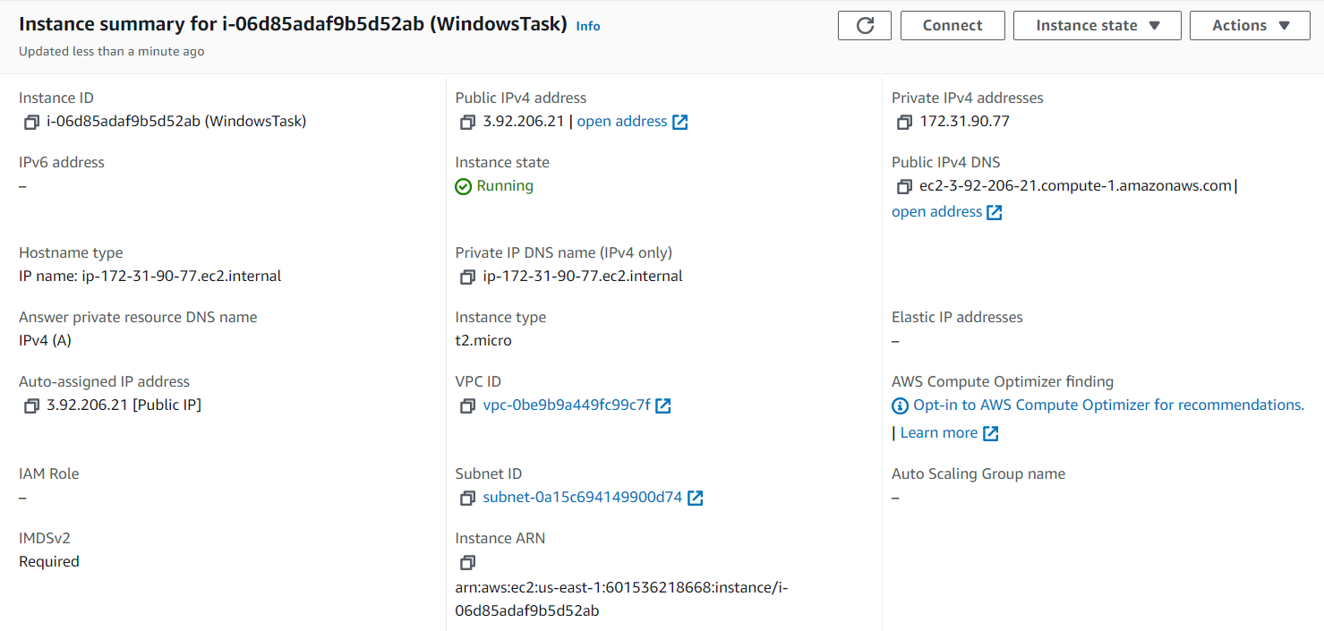

Create EBS volume of 5 GB

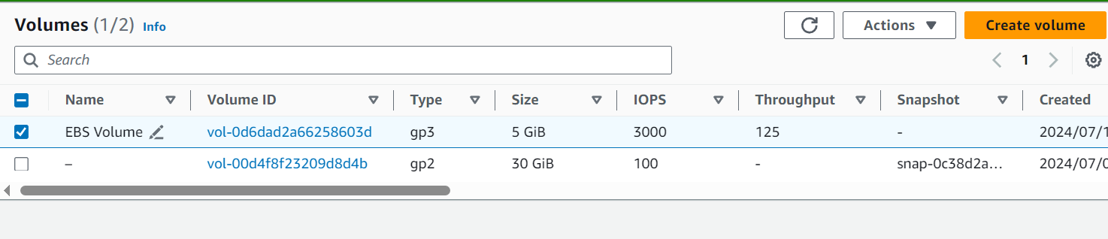

Attach volume to EC2 instance created

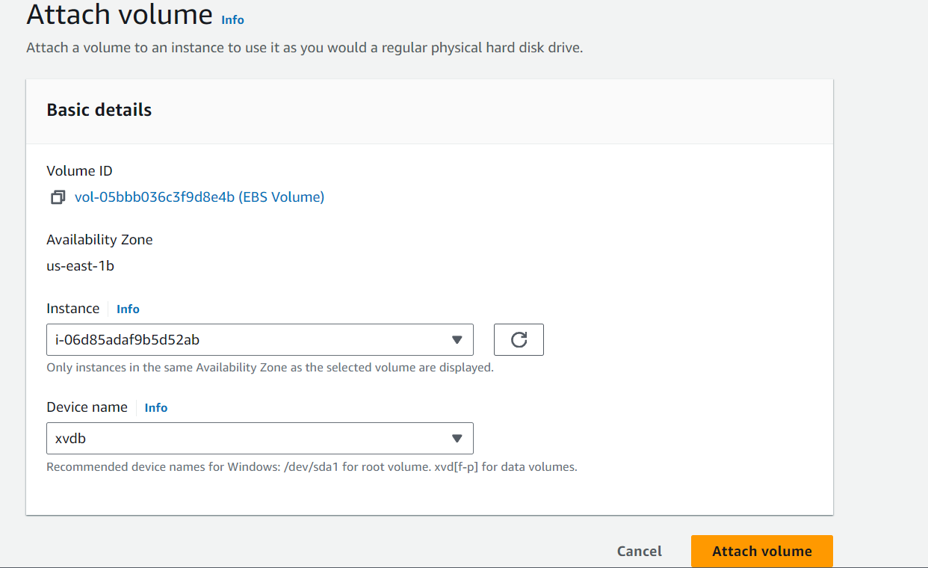

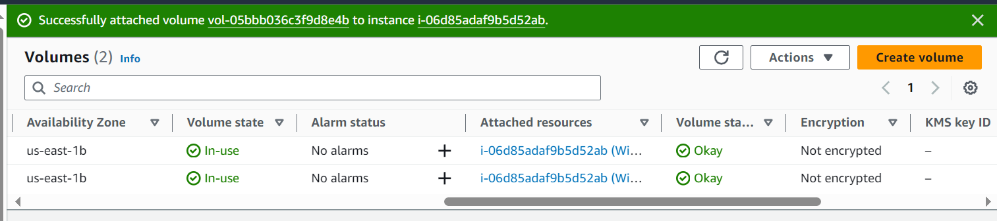

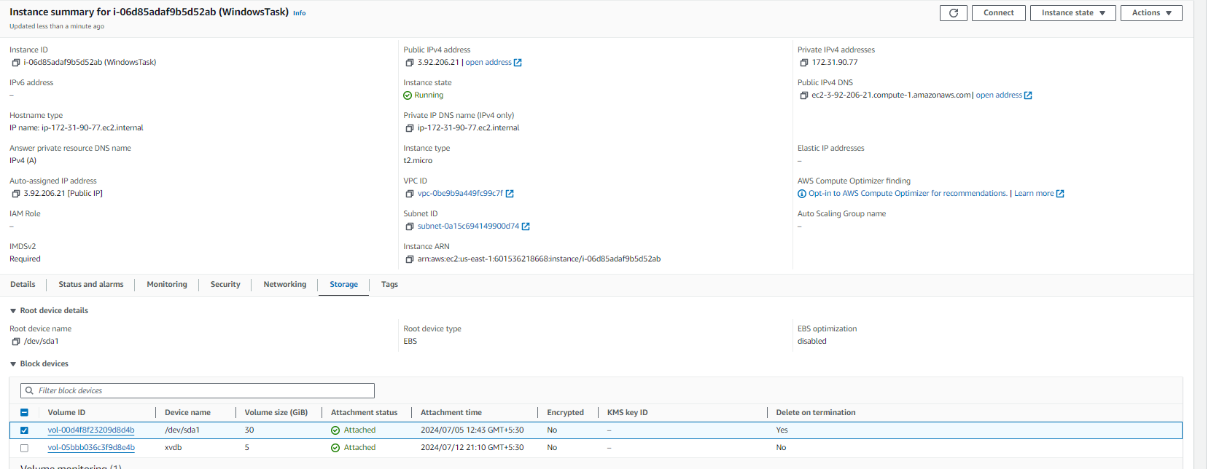

and take a snapshot :

1. Take a snapshot of volume

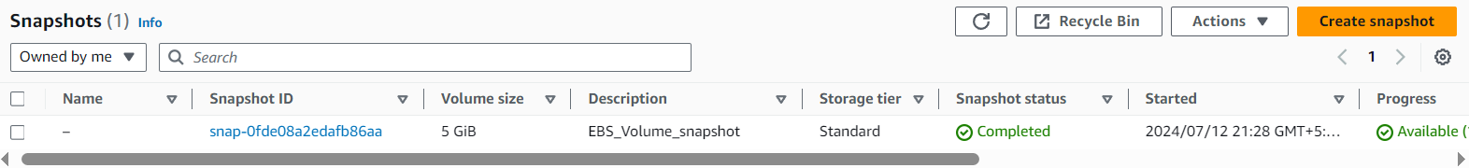

Create a volume using the snapshot

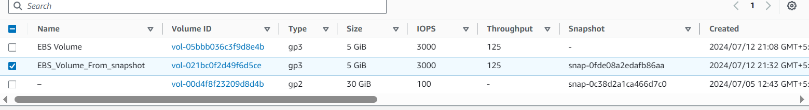

Attaching the volume created from above snapshot to EC2 instance created

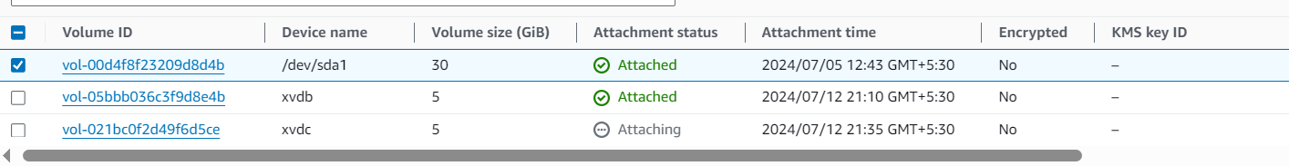

1. Taking the snapshot of instance root volume



Create a volume from that snapshot.

